FAWN HackTheBox [Very Easy]

Target Machine IP 10.129.1.14

Task 1

What does the 3-letter acronym FTP stand for?

**File Transfer Protocol**

Task 2

What communication model does FTP use, architecturally speaking?

FTP is built on a **client-server model** architecture using separate control and data connections between the sclinet and the server

Port : 21 for control, 20 for data transfer

Task 3

What is the name of one popular GUI FTP program?

**FileZilla**

Task 4

Which port is the FTP service active on usually?

**21 tcp**

HINT : it is important to write port line “21 tcp or 23 telnet etc” not just Port 21 or Port 23

Task 5

What acronym is used for the secure version of FTP?

SFTP (Secure File Transport Protocol)

Task 6

What is the command we can use to test our connection to the target?

ping

Task 7

From your scans, what version is FTP running on the target?

Using nmap -sV 10.129.1.14

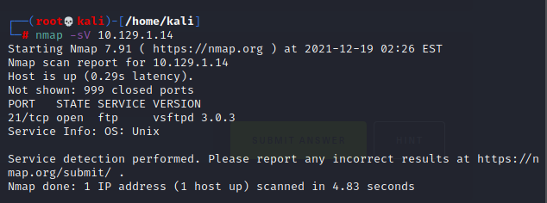

So, the answer is **vsftpd 3.0.3**

**Task 8**

From your scans, what OS type is running on the target?

From the Task 7 result we can see that the machine running on **Unix** OS

Task 9

Submit root flag

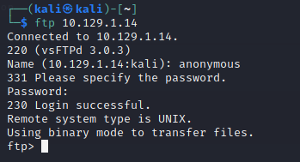

Using ftp service

We can login using anonymous for every ftp service and **blank password “ “**

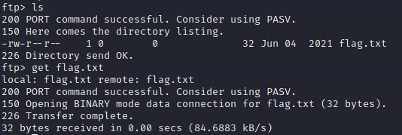

We download the flag.txt from the machine.

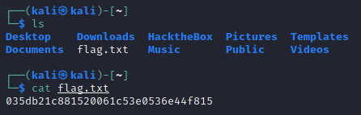

Now we know that the flag is 035db21c881520061c53e0536e44f815